|  |
| --- |
| On This Day  Game Design Document |

Version 1.0

December 1, 2017

Adam Hubble

**Game Title**

On This Day

**Intended Game Systems**

Computer (PC) – Steam

Xbox One (all generations) – Xbox Live

PlayStation 4 (all generations) – PlayStation Network

Nintendo Switch – Nintendo Switch Online

Mobile (mobile phone and tablet) – Google Play Store and Apple Appstore

**Target Audience**

15 – 35 years of age demographic

**Intended Entertainment Software Rating Board (ESRB) rating**

Teen – the game will incorporate violence and displays of blood

**Summary of the game story**

On this day… we shall live and die. Conceding the widespread epidemic of virus ‘Drought-9’, the toll on humanities population, has resorted to quarantining! You’re alone in a distant city from ‘Containment B’; amongst the empowering presence of zombies, you must survive and get to that quarantine zone! Battle through the endless encounter of zombies, and environmental obstacles in numerous terrains. Lust to live and reach the sanctuary that is ‘Containment B’; if you fail, humanity will too, so be sure to get violent!

**Summary of the game outline**

Player(s) battle through wave-focused encounters with zombies and obstacles that are a variance to the current environment; where the player(s) are present. Players must survive utilising the arsenal of gun-orientated weaponry that is available to them, with the addition of limited speed striking and bombing capabilities. As the player(s) progress through each round, the strength of the zombies increases and the characters environment changes; ultimately leading to a boss battle, as the determinant to the players advancing in the game - ‘reaching the containment’. Each player is assigned with an independent yet equal health capacity and life counter of three; once all health and lives are depleted the game ends, resulting in failure to reaching the containment. Upon failure, the player(s) are required to fully restart the game, from the initial round. Progression is saved beyond the narrative stage of the player successfully reaching the containment. Future expansions to the game will feature, additional quests to rescue external survivors, farming external resources to maintain living conditions within the containment and collect and deliver a cure for the infection. This will act as a continuation to the main narrative; and is subject to play only when the player(s) complete the initial boss battle.

**Modes of Gameplay**

Time-intervals – real-time gameplay focus

* The gameplay focuses upon simultaneous play of numerous players; which anticipates players to think reflexively rather than reflectively. Such interval is suited to escalation.

Genre focus – action

Player modes – predominant focuses: online multiplayer and single player

* Player modes will be more focused upon the demand for online multiplayer and single player gameplay, however for player satisfaction and narrative compatibility, the game incorporates the following modes of gameplay.

Player modes of “On This Day”:

* Single player – ability to play alone, no non-playable characters are incorporated (NPC’s)
* Online multiplayer – ability to play with others in a real-time environment, encourages team-base play
* Local multiplayer – ability to play with peers simultaneously on the same device and screen
* LAN multiplayer – ability to play on the same network, and have an independent simulation

**Unique Selling Points (USP)**

* Be immersed in this action-packed journey of zombie slaying, why not share the experience with friends?
* Battle your way through hordes of zombies, environmental obstacles and bosses.
* From machine guns to rocket projectiles to powers? You decide the takedown of your foe, with an expanding availability of weapons as you progress your way to safety!
* Beat the base boss to progress to extended levels of mayhem!
* Single player or multiplayer mode? With both options, you can find your balance!
* Multiplayer mode features four-player gameplay. How much chaos is that?

**Competitive products**

* Realm of The Mad God
* Dead Nation
* Zombie Night Terror
* Still Alive
* Dead State

Table of Contents

Title Page 5

*1.1 Game Title* 5

*1.2 Intended Game Systems* 5

*1.3 Target Audience* 5

*1.4 ESRB Rating* 5

*1.5 Expected Completion Date* 5

*1.6 References* 6

Game Outline 6

*2.1 Game Story Summary* 6

*2.2. Gameplay Outline* 6

*2.3 Competitive Products* 7

Character and controls 7

*3.1 Player Control* 7

*3.2 Character Overview* 7

*3.3 Character Appearance* 7

*3.4 Character Interactions* 8

*3.5 Controls* 8

Main Gameplay Concepts 9

*4.1 Sequence of Gameplay* 9

*4.2 Game Basis* 9

*4.3 Mini-games* 9

Game World 10

*5.1 Appearance* 10

*5.2 Player Establishments* 10

*5.3 Location and Narrative* 10

*5.4 Map of the World* 11

Game Experience 11

*6.1 Initial Player Engagements* 11

*6.2 Music and Sounds* 11

*6.3 Navigation through Game States* 11

Gameplay Mechanics 12

*7.1 Mechanics, hazards, power-ups and collectibles* 12

Enemies 13

*8.1 Types of enemy* 13

*8.2 Player encounter* 14

Cutscenes 14

*9.1 Cutscene appearance* 14

Bonus Materials 15

*10.1 Game incentives* 15

*Game Design – Presentation* 16

# Title Page

## 1.1 Game Title

“On This Day”, proposes to provide a nostalgic conceptualisation of a zombie apocalyptic narrative basis. “On This Day” attempts to indicate the occurrence of an event, in context to the narrative, the indication is to the state of being alive or dead. In essence the game title encourages a survival theme.

## 1.2 Intended Game Systems

“On This Day” will be produced for the following platforms: Computer (PC Windows), Nintendo Switch, Mobile phones and tabular devices supporting Google Play Store and Apple Appstore, and also all generations of the Xbox One and PlayStation 4 consoles. This document primarily concerns the computer platform of the game.

## 1.3 Target Audience

“On This Day” incorporates various violent orientations, from mild blood exposure, use of bullet and explosive based weaponry and focus on an apocalyptic narrative; the game appeals to gamers who share interest in competitive and multiplayer play, and further attend to a fast-paced action experience. The production aims to accumulate an audience, predominantly male, who are aged between fifteen and thirty-five years old.

## 1.4 ESRB Rating

“On This Day” will accommodate the ‘teen’ category. Based upon the specification of the game, “On This Day” will primarily include violence and minimal screening of blood. For such, the game will be suitable for ages of thirteen and above.

## *1.5 Expected Completion Date*

“On This Day” will be fully developed and ready for publication August, 2018; the game will be published and available on: PlayStation 4 and Xbox One, mobile devices, computer (pc windows) and the Nintendo Switch by December, 2018. An open-beta will commence November, 2018; enabling any necessary adjustments to be made to the game pre-release. Adjustments will be based upon a company issued electronic survey, sampling player feedback in response to their beta experience.

*1.6 References*

[1] ONLINE TECH TIPS (2008) Computer Keyboard [Online Image]. Available from: <https://www.online-tech-tips.com/computer-tips/right-click-keyboard-shortcut/> [Accessed 6/12/17].

# Game Outline

## 2.1 Game Story Summary

On this day… we shall live and die. Conceding the widespread epidemic of virus ‘Drought-9’, the toll on humanities population, has resorted to quarantining! You’re alone in a distant city from ‘Containment B’; amongst the empowering presence of zombies, you must survive and get to that quarantine zone! Battle through the endless encounter of zombies, and environmental obstacles in numerous terrains. Lust to live and reach the sanctuary that is ‘Containment B’; if you fail, humanity will too, so be sure to get violent!

Setting - the game proposes to take place amongst the present-day in a city environment within the United States of America. Through progression within the game, the character(s) will explore other environments: in example woodlands and rural areas.

Character – the narrative has focus upon the protagonist who sets out to reach a containment zone in a distant city. The character situates as an average female civilian, whose father - a hunter - trained her to use various weaponry and most importantly, the ability to survive. Inside the multiplayer experience, a range of characters is implemented; all are also assumed to lead typical American lifestyles.

Conflicts – the narrative focuses upon an apocalyptic state of present-day America. The characters conflicts are associated to zombified humans, and environmental obstacles; such as fleeing animals, which are a variance to the characters current environment. Their goal is to decrement the life counter of the player until the point of the games state of end.

## 2.2. Gameplay Outline

Player(s) battle through wave-focused encounters with zombies and obstacles that are a variance to the current environment; where the player(s) are present. Players must survive utilising the arsenal of gun-orientated weaponry that is available to them, with the addition of limited speed striking and bombing capabilities. As the player(s) progress through each round, the strength of the zombies increases and the characters environment changes; ultimately leading to a boss battle, as the determinant to the players advancing in the game - ‘reaching the containment’. Each player is assigned with an independent yet equal health capacity and life counter of three; once all health and lives are depleted the game ends, resulting in failure to reaching the containment. Upon failure, the player(s) are required to fully restart the game, from the initial round. Progression is saved beyond the narrative stage of the player successfully reaching the containment. Future expansions to the game will feature, additional quests to rescue external survivors, farming external resources to maintain living conditions within the containment and collect and deliver a cure for the infection. This will act as a continuation to the main narrative; and is subject to play only when the player(s) complete the initial boss battle.

## 2.3 Competitive Products

In focus of existing game productions, there are few currently existing video games in competition with “On This Day”. All of which incorporate similarities within theme, gameplay focus and objectives.

* Realm of The Mad God
* Dead Nation
* Zombie Night Terror
* Still Alive
* Dead State

# Character and controls

## 3.1 Player Control

Players(s) will control a range of characters within the multiplayer mode of gameplay, all of which adopt typical civilian lifestyles in present-day America, yet have different nationalities. In focus of the single player mode of gameplay, the character alike multiplayer characters, will also conform to a typical American civilian lifestyle.

## 3.2 Character Overview

‘Julia’ stars as a Polish-born Biochemist, who is employed at Mercury Labs upon the narrative initiation. ‘Julia’ is the focal character within the game, through which her life forms the narrative basis of the game. With her specialised knowledge within Biochemistry, ‘Julia’ has the potential to formulate a cure to the infection that continues to near humanity to its extinction. Her former interaction with her father - a hunter, has enabled her to be physically and mentally competent for survival.

## 3.3 Character Appearance

‘Julia’ stands to be 5’7 in height with a well-defined ectomorph body curvature. ‘Julia’ conforms to an olive skin complexion type, hazel infused pupils, blonde hair tone and a rouge lip colour. As a female, she maintains her appearance to a regular basis. ‘Julia’ is depicted to be wearing thermal leggings, a fur hooded puffer coat, boots, scarf and mitten gloves to complement the cold conditions of the winter season.

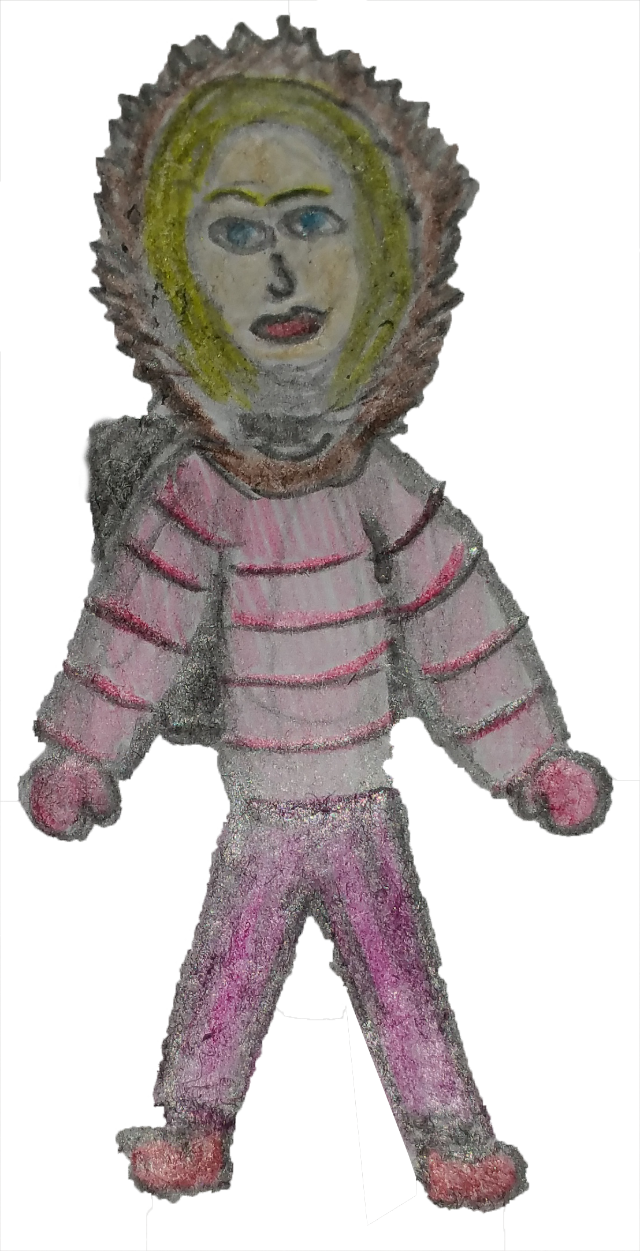

## 3.4 Character Interactions

Characters possess the core abilities to shoot and walk; characters do not possess the ability to jump and interact with objects that could change their mode of movement – driving vehicles. Additionally, characters have a supernatural focused ability of speed bursts; the ability is restricted to three uses from the game initialisation, but is regenerative from power-up pickups. This concept also applies to the final ability of characters, being able to set off a detonation. When a character walks over a spawned weapon, the character will equip the weapon, the weapon remains in possession of the player until its ammo fully depletes – unless manually dismounted from player. After ammo depletion, the characters weapon will revert to the default weapon.

## 3.5 Controls

“On This day” claims compatibility with all platforms, inevitably the game controls will vary between each platform. As this document is primarily focused upon the computer platform, computer control is in focus; computers have the largest potential dynamic of controls to specify. The default control layout of the game aims to be generic for player comfort and ease of initial gameplay, across all platforms.

Computer (PC):

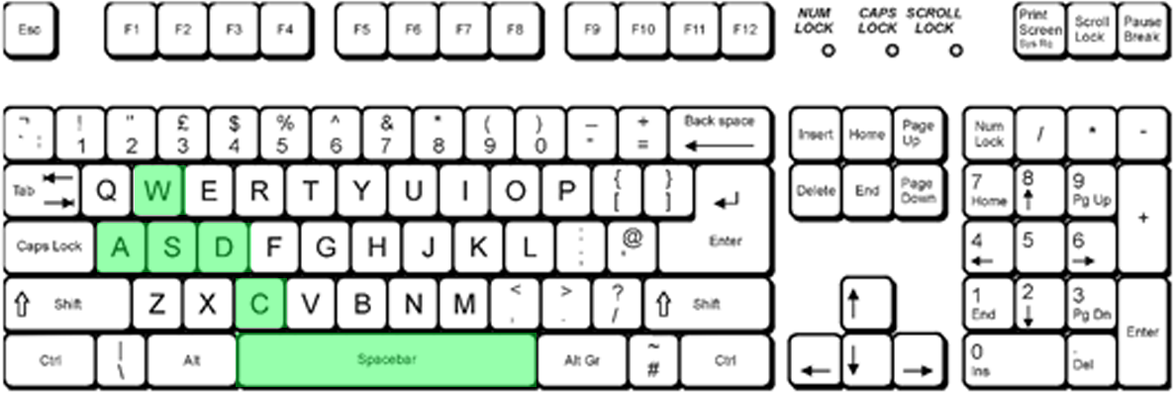

[1] Keyboard highlighting keys that players can use to perform actions in-game

Keyboard:

* W – Character movement up
* A – Character movement left
* S – Character movement right
* D – Character movement down
* C – Cycle camera zoom
* Spacebar – Detonation

Mouse:

* Left click (hold) – Shoot weapon
* Right click – Speed burst

# Main Gameplay Concepts

## 4.1 Sequence of Gameplay

The round-based focus of gameplay is identified by a round counter, which increments in correlation to round completion; such is visible from within the players HUD. As each round is based upon a set time period, a counter becomes visible within the last remaining minute of every round, also visible within the players HUD. After a set number of rounds, players will be presented with a cut scene to introduce new occurrences within the narrative, which will accommodate their transition to different locations within the game world.

## 4.2 Game Basis

“On This Day” focuses upon a round-based orientation of gameplay, as the rounds increment, the difficulty of the enemy’s increments proportionally. Difficulty enhancement is defined in terms of increased health and movement speed over time; providing the simulation of an increased number of enemies. From the completion of each round, players can progress through the narrative in attempt of reaching the end goal: ‘Containment B’. Each round is time orientated, where after a set interval, players can leave the current environment and progress to the next. Inevitably their environment changes, as does the obstacles. In focus of chapters of the narrative, additional quests like chapters become available to players upon the completion of the base chapter - reaching the containment.

## 4.3 Mini-games

Throughout the game, players are able to obtain increased rates of weapon damage, from completing waves without losing a life. A life is composed of four consecutive hits from zombified humans in succession, or alternatively a life may be taken instantly if a player makes contact with a dynamic obstacle. If the player loses a life or more, their ammo type remains the same. The more rounds that players survive consecutively, the more damage their weapons deal over time. However the incrementing rate of damage of the weapons depreciates per round, if players successfully maintain all their lives for a consecutive number of rounds. The progress of the mini game can be referred to within the players HUD.

# Game World

## 5.1 Appearance

“On This Day” features a winter environment, where grounds and objects appear to have a white coverage of snow. Such seasonal environment is enhanced by the constant precipitation of snow. The game world itself basis itself upon a city location, where the environments are mostly urban focused, but have loosely-defined infrastructure. Buildings and surrounding terrain appear to be unmaintained, windows broken, door left open and roads and pathways are littered. Notably the game world lacks light intensity due to the continuation of snow, and provides a nightly period of day throughout.

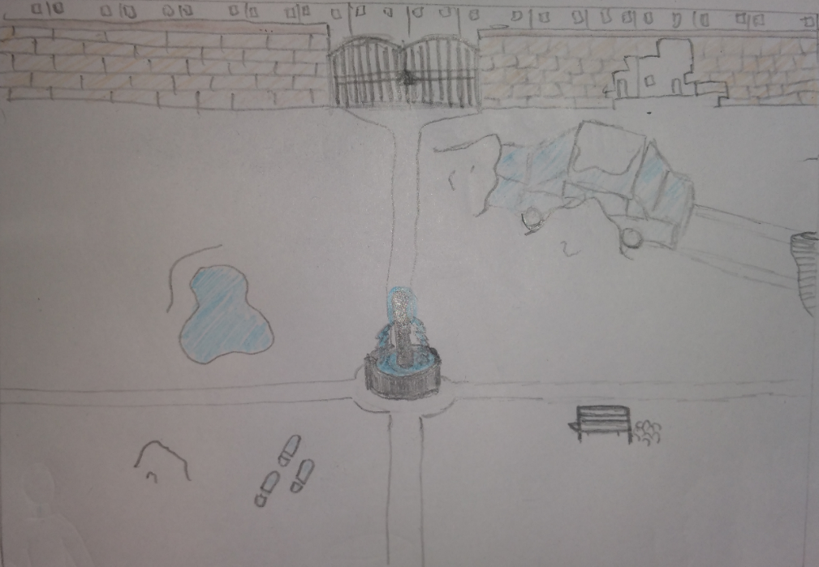

Game world within the public park location, showcasing the top down camerawork and environment

## 5.2 Player Establishments

In focus of player establishments, players will find large populations of zombified humans and fleeing animals – as acting obstacles, which emerge from off-screen terrains, as a top-down viewed game.

## 5.3 Location and Narrative

The locations within the game world maintain focus on urban environments, more specifically streets, shops, transport spaces and also public spaces – parks and sporting grounds. The environments relate to places affected by the infection, as the whole world experiences the infection within the narrative, almost all locations are suited – including remote woodlands. But more open-spaced areas are required to suffice for the waved orientation of gameplay.

## 5.4 Map of the World

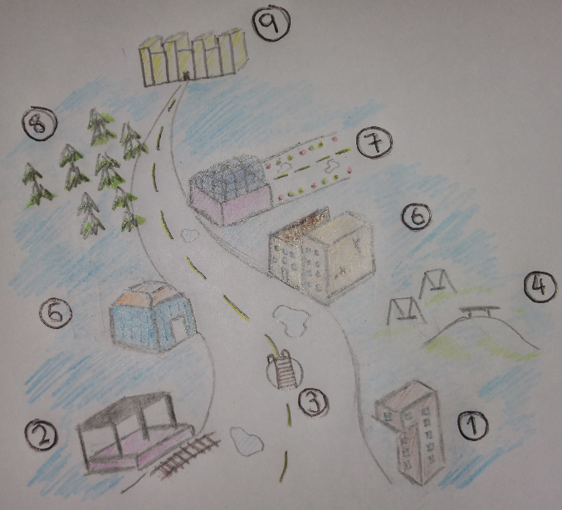The numbers correspond to player’s movement throughout the game world, chronologically. The following locations within the game world:

1 – Laboratory

2 – Train station

3 – Sewer

4 – Public park

5 – Shopping mall

6 – Public library

7 – Airfield

8 – Woodland

9 – Containment B

# Game Experience

## 6.1 Initial Player Engagements

Upon the initialisation of “On This Day”, players are presented with a cinematic cutscene experience to introduce the narrative; such dynamic enables players to understand the purpose of play and further intends to encapsulate player interest. In focus of play proceeding from the cutscene sequence, players are provided with an optional tutorial basis of gameplay. The tutorial is optional, and intends to inform players of control schemes. Beyond the tutorial, players will start the narrative, where the character is shown to be leaving an apartment building; and attracts attention to a hoard of zombified humans. Players are initially set out to survive the wave, which transitions into the progression of the narrative and continuation of waves. The intension is to provide players with a fully immersive experience from the beginning, were players will be gratified by the action-packed gameplay, and nostalgic environments.

## 6.2 Music and Sounds

Focusing upon music, “On This Day” incorporates melodramatic instrumental music pieces, such enhances the intended nostalgia and further immersion of the gameplay. The music focuses upon generic horror vibes, and aims to cinematise the gameplay. To accompany the music, numerous sound effects of shooting, groaning, walking and character narration are used to auditory support the visuals of the game

## 6.3 Navigation through Game States

During the initiation of the game, the main menu provides players with a selection of game modes – single player, local play, online multiplayer and co-op mode - and also game settings to access. Additional menus can be accessed within a current game session; once ‘a’ player has opened their menu, all players’ game sessions are paused for a period of fifteen seconds. This is implemented to enforce the teamwork basis of the game. The pause is periodic, to prevent a permanent playing obstruction to other players.

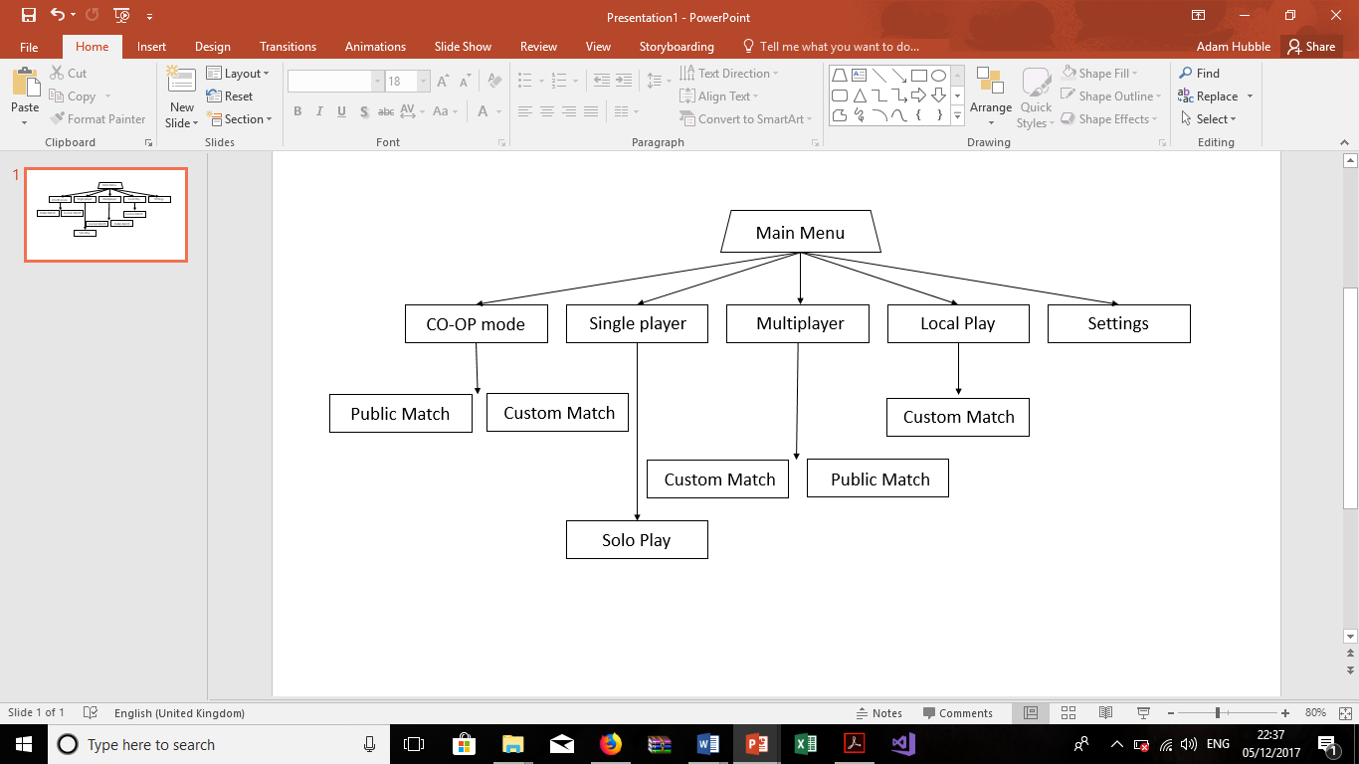

# Gameplay Mechanics

## 7.1 Mechanics, hazards, power-ups and collectibles

In focus of hazards, a player’s life count will be threatened not only by the core enemy: zombified humans, but also dynamic obstacles. Within each location of the game world, fleeing animals will spawn and have a randomly generated horizontal or vertical movement across the screen. The obstacles enhance the difficulty of the survival focus, where the player’s movement space is drastically reduced; additionally if a player makes contact with an animal, the player loses a life. In regards to environmental challenges, numerous locations will encourage environmental obstacles of slippery surfaces and blizzards – as a winter season focused narrative. Both mechanics are implemented to distort player movement, and in turn increase the difficulty of gameplay. Through which, blizzards directly affect the camera of the player via a periodic white coverage; slippery surfaces are also present upon the players arrival to the environment and do not change periodically.

Within the game, players are presented with two ‘power-up’ abilities, which provide the capabilities of a player to run significantly faster through zombies in a short burst, and direct a bomb detonation on the player’s current position. Both power-up abilities are quantified to three from the start of each game session, however additional power-ups can be obtained from the killing of zombified humans; a power-up spawn is randomised. Similarly players have the ability to pick up various weapons in their environment upon spawn, the weapons have a limited ammo capacity but deal a significant rate of damage in comparison to the default weapon; gameplay is temporarily eased. Like power-ups, weapon spawns are randomised from location to location.

Throughout the game, players can collect objects throughout the environments, in the form of collectable items. Successful collection of objects provides character customisation to players. That of clothing skins, weapon skins, and shooting aesthetics. The objects themselves are related to survival equipment and consumables – examples being food and medicine, the objects are not obvious to players and are obtainable through a variation of unspecified challenges. The intention, is to maximise the players playing capability; where better play will reveal the collectibles to players – not losing lives and health.

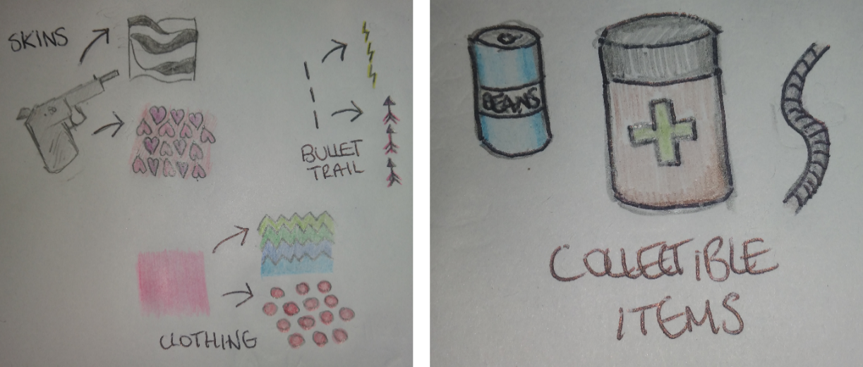

Exampling aesthetic unlocks and collectible items

# Enemies

## 8.1 Types of enemy

“On This Day” incorporates a variation of enemies, all derived from the concept of zombified humans. Each variation has its own unique characteristics and is considered as an addition to the thrill of the gameplay, through which the spawn of different zombies has implications on a players decision making.

Types of enemy

* Drencher – standardised zombie phenotype which resembles a human civilian to most extent. Its movement speed is moderately quick, and damage dealt is small; requires five consecutive hits to deplete player health. The enemy’s all-rounded performance in addition to an incrementing health count per round, enables the gameplay to gradually incline in difficulty.
* Grunt – child-like zombie phenotype which resembles a human civilian to most extent. Its movement speed is very quick, and damage dealt is minimalistic; requires ten consecutive hits to deplete player health. The enemy’s fast movement speed encourages panic within player’s movement, until the point of entrapment.
* Mortar – mutated zombie phenotype which resembles an oversized human in perspective of height and width, and displays physical impairments of disproportionate muscle size and positioning. Its movement speed is slow, but damage dealt is high; requires two consecutive hits to deplete player health. The enemy acts as a path obstruction for players.
* Bootlegger (boss) – mutated zombie phenotype with metal plating and sound amplification technologies embedded throughout its lean anatomy, allowing it to scream and disorientate player’s vision. Its movement speed is very quick in short bursts, and only travels straight within the bursts, its damage is maximised; requires one hit to deplete player health. The enemy’s large health capacity, high damage, fast movement speed and disorientation ability makes narrative progression seem challenging for players.

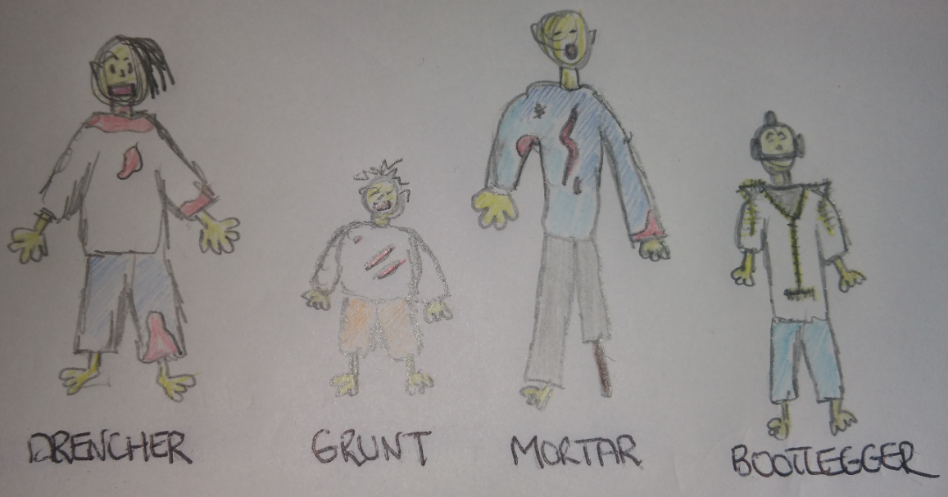

Enemy types

## 8.2 Player encounter

Within the game, enemies are defeated via gun orientated weaponry, all enemies have the same vulnerability to weapons, but some enemies are more resistant due to a higher health capacity. The Mortar and Bootlegger enemies exemplify this. Players are required to use sufficient character movement to overcome the quantities of zombies, during periods where health significantly empowers the weapon damage dealt. Players can use weapon pick-ups and power-ups to assist reducing the number of zombies.

# Cutscenes

## 9.1 Cutscene appearance

“On This Day” utilises many cutscenes throughout to maintain the narrative focus of the game, the cutscenes aid players with their understanding of the narrative development. The cutscenes within the game are presented as image slideshows with narration, and are accompanied by subtitles.

Cutscenes are implemented within the initiation and the ending of the base narrative. During play, cutscenes make an appearance for the completion of every five rounds; where players encounter a change in location within the game world. Cutscenes within this context are triggered by players leaving a completed location; players are also provided the option to skip cutscenes, in case of annoyance, player satisfaction is considered.

In focus of the narrative initiation, the cutscenes provide context to the narrative occurrence of the epidemic and its widespread effect on the human population and living environment. And moreover, provide scope on the objective of the game - to reach the containment. In relation to the base narrative ending, the cutscenes provide insight to the character reaching the containment and the life within it. The cutscenes also provide insight to narrative continuation in the form of a cliff-hanger, the narrative continuation is downloadable content and founds new objectives to players, which is implied within the cutscenes.

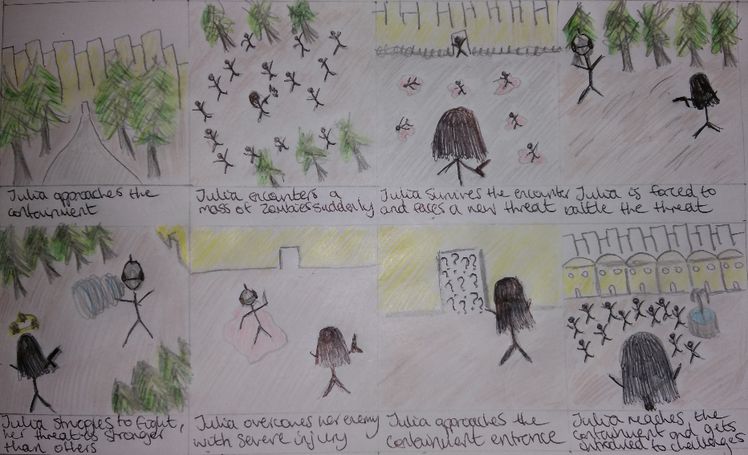

Storyboard showcasing end cutscene of the base narrative

# Bonus Materials

## 10.1 Game incentives

“On this day” provides four narrative continuations, as downloadable content for players. The expansions will provide further scope into various locations of the game world, which attempts to imitate an American-styled city. The expansions will share a similar focus of creating and delivering a counter to the virus and also collecting survival essentials and rescuing survivors, but the environments become significantly more challenging to players.

Unlockable content consists of aesthetic orientated items, which are available to players using collectible item currency. Unlocks are available in the main menu sequence of the game, and are equitable from there also. Using a currency encourages players to replay the game in the form of playthroughs; as an acting quest. Notably more aesthetically appealing items, requires a higher cost and current playthrough to unlock.

Achievements will provide gamerscore currency to players upon completion, determined by the platform. Achievements can be obtained by completing various challenges throughout the game, some achievement objectives are anonymous to players, whereas most are specified. The majority of achievements have an in-game focus; a few achievements have a menu focus. In-game achievements generally require players to perform well, reach objectives and accumulate set amounts of collectible items.

Playthroughs are available to players based upon difficulty, after the completion of the base game, players will be prompted with menu to increase the difficulty of gameplay; difficulty is based upon fastened rates of enemy spawns. There are a total of three playthroughs: rookie, adventurer, and conqueror; which only become available to a player once the next difficulty of playthrough is complete. Playthroughs act as an incentive to replay the game, and unlock more aesthetically pleasing items; which become available only at higher levelled playthroughs.

## *Game Design – Presentation*

